Task 1

A. Display a list of all property names and their property id’s for Owner Id: 1426.

SELECT p.Id, p.name FROM OwnerProperty as op

inner join property as p on op.PropertyId = p.id

where ownerid = 1426

B. Display the current home value for each property in question a).

SELECT p.id, p.Name, phv.Value

FROM Property p

join OwnerProperty op on p.id = op.PropertyId

join PropertyHomeValue phv on p.id = phv.PropertyId

WHERE op.OwnerId = 1426

and phv.IsActive = 1

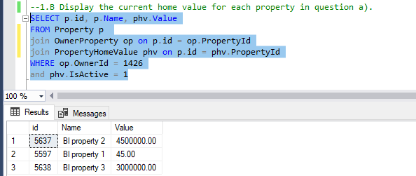

C. For each property in question a), return the following:

1. Using rental payment amount, rental payment frequency, tenant start date and tenant end date to write a query that returns the sum of all payments from start date to end date.
2. Display the yield.

SELECT p.Id 'Property ID',

p.Name 'Property Name',

tp.PaymentAmount,

trt.Name 'Payment Type',

tp.StartDate,

tp.EndDate,

Cast(Round((CASE

WHEN tp.PaymentFrequencyId ='1' THEN tp.PaymentAmount\*DATEDIFF("Week",tp.startdate,tp.enddate)

WHEN tp.PaymentFrequencyId ='2' THEN tp.PaymentAmount\*DATEDIFF("week",tp.startdate,tp.enddate)/2

WHEN tp.PaymentFrequencyId ='3' THEN tp.PaymentAmount\*DATEDIFF("Month",tp.startdate,tp.enddate)

ELSE null END),0) as int) as TotalPayment

FROM Property as p

INNER JOIN OwnerProperty as op ON p.id = op.PropertyId

INNER JOIN PropertyHomeValue as phv ON op.PropertyId = phv.PropertyId

INNER JOIN TenantProperty as tp ON p.Id = tp.PropertyId

INNER JOIN TargetRentType as trt ON tp.PaymentFrequencyId = trt.Id

WHERE op.OwnerId = 1426 AND phv.IsActive = 1

C. ii Display the yield.

select pf.yield, op.PropertyId

from PropertyFinance as pf

inner join OwnerProperty as op on op.PropertyId = pf.PropertyId

where op.OwnerId = 1426

D. Display all the jobs available

SELECT a.Id, a.PropertyId, a.JobDescription FROM Job as a

INNER JOIN JobMedia as c on a.Id = c.Id

WHERE c.IsActive = 1

E. Display all property names, current tenants first and last names and rental payments per week/ fortnight/month for the properties in question

SELECT p.Name 'Property Name',

CONCAT(pe.FirstName, ' ', pe.LastName) 'Tenant Name',

tp.PaymentAmount 'Rental Rate',

tpf.Name 'Payment Frequency'

FROM dbo.OwnerProperty as op

INNER JOIN Property as p on p.Id = op.PropertyId

INNER JOIN TenantProperty as tp on tp.PropertyId = p.Id

INNER JOIN TenantPaymentFrequencies as tpf on tpf.Id = tp.PaymentFrequencyId

INNER JOIN Person pe on pe.Id = tp.TenantId

WHERE op.OwnerId = 1426

